ECA0302- SIGNALS AND SYSTEMS

Experiment 1
Generation and Classification of Continuous-Time and Discrete-Time Signals
Objective 1: Generate and Visualize Basic Continuous-Time Signals
CODE :
clc;
clear;
close all;

t = -1:0.001:1;
A = 2;
f0 = 5;
a = 1;

imp = double(abs(t)<0.0005);
step = double(t>=0);
ramp = t.*step;
expSig = exp(-a*t).*step;
sinSig = A*sin(2*pi*f0*t);

figure;
subplot(3,2,1);
plot(t,imp); grid on;
title('Unit Impulse');
xlabel('t'); ylabel('Amplitude');

subplot(3,2,2);
plot(t,step); grid on;
title('Unit Step');
xlabel('t'); ylabel('Amplitude');

subplot(3,2,3);
plot(t,ramp); grid on;
title('Ramp');
xlabel('t'); ylabel('Amplitude');

subplot(3,2,4);
plot(t,expSig); grid on;
title('Exponential');
xlabel('t'); ylabel('Amplitude');

subplot(3,2,5);
plot(t,sinSig); grid on;
title('Sinusoidal');
xlabel('t'); ylabel('Amplitude');
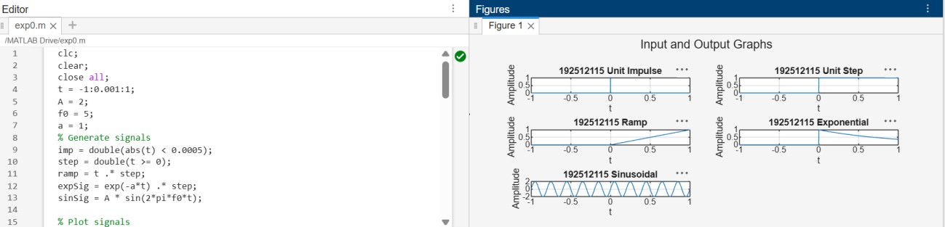

OBJECTIVE 2: To generate and visualize basic discrete-time signals and analyze their amplitude and time-index characteristics
CODE :
clc;
clear;
close all;

n = -20:20;
A = 2;
f0 = 0.1;
a = 0.1;

imp = double(n==0);
step = double(n>=0);
ramp = n.*step;
expSig = (0.8).^n .* step;
sinSig = A*sin(2*pi*f0*n);

figure;
subplot(3,2,1);
stem(n,imp,'filled'); grid on;
title('Unit Impulse');

subplot(3,2,2);
stem(n,step,'filled'); grid on;
title('Unit Step');

subplot(3,2,3);
stem(n,ramp,'filled'); grid on;
title('Ramp');

subplot(3,2,4);
stem(n,expSig,'filled'); grid on;
title('Exponential');

subplot(3,2,5);
stem(n,sinSig,'filled'); grid on;
title('Discrete Sinusoid');

xlabel('n');

OBJECTIVE 3 : To generate and classify continuous-time and discrete-time signals as periodic or aperiodic based on their periodicity characteristics
CODE :
clc;
clear;
close all;

t = 0:0.001:2;
f0 = 5;

xP = sin(2*pi*f0*t);
xA = exp(-t);

figure;
subplot(2,1,1);
plot(t,xP); grid on;
title('Periodic Signal: Sinusoid');
xlabel('Time (s)');
ylabel('Amplitude');

subplot(2,1,2);
plot(t,xA); grid on;
title('Aperiodic Signal: Decaying Exponential');
xlabel('Time (s)');
ylabel('Amplitude');
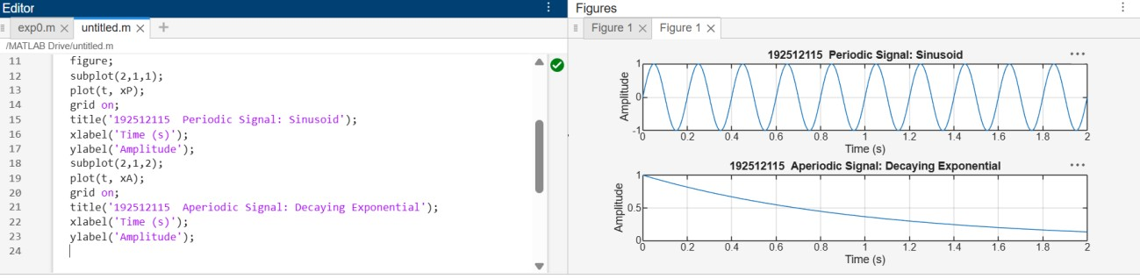

OBJECTIVE 4 : To decompose a given signal into its even an odd components and verify the reconstruction of the original signal
CODE :
clc;
clear;
close all;

t = -1:0.001:1;
x = sin(2*pi*5*t) + 0.5*cos(2*pi*3*t);

xr = fliplr(x);
xe = (x + xr)/2;
xo = (x - xr)/2;
xrec = xe + xo;

figure;
subplot(2,2,1);
plot(t,x); grid on;
title('Input x(t)');

subplot(2,2,2);
plot(t,xe); grid on;
title('Even Component');

subplot(2,2,3);
plot(t,xo); grid on;
title('Odd Component');

subplot(2,2,4);
plot(t,xrec); grid on;
title('Reconstructed x(t)');

fprintf('Maximum reconstruction error = %g\n',max(abs(x-xrec)));

